
Ladywood Unite – How to make a complaint
Complain using either:
- Council’s online complaints proforma
- Write a letter
- Email
Using Councils Online Proforma
Either https://www.birmingham.gov.uk/complaints or google Birmingham complaints.

Follow through the instructions which are fairly straightforward:

- Yes, I want to login and track this submission
- Make a complaint (Raise a complaint)
- Do you want to track this submission (yes, I want to track this submission)
- Complaint box – your involvement…..complaint is about (your service is not listed)
- Please provide details of your complaint (box)
- Please state how you would like us to do to resolve the issues? (box)

This is the online format. You need to fill in the boxes

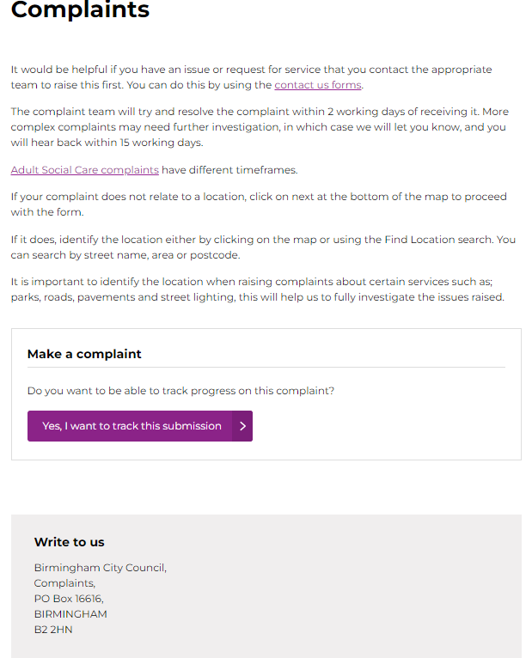 | 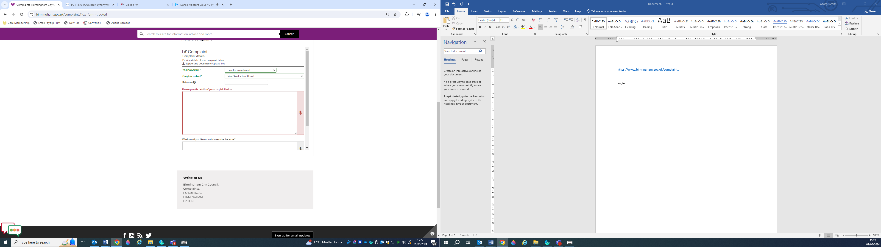

Rationale for making a complaint:
The main reason is that you have experienced or will experience an injustice in relation to the Ladywood Regeneration Project
Remember that our councillors and MP are here to serve us – the way they behave would suggest otherwise! They are voted in by us and they are paid through our taxes. It’s always worthwhile remembering that our councillors have spent over £32million on electrical work and having the Council House decorated (£29million funded through borrowing) whereas 23,000 BCC social homes do not meet the Decent Home Standard – 38% of stock according to a letter from the Commissioners 23 February 2024. BCC’s Homelessness Prevention Strategy Over 23,000 households on the housing register are in need of a home. Nearly 5000 households currently in temporary accommodation and within 15 years homelessness in the City is due to increase by 37%
What will happen if I submit an online complaint?

Stage 1 – Investigate the complaint
BCC will acknowledge your complaint within 2 working days.
The Directorate that provided the service will investigate the complaint and respond within 15 working days (3 weeks)

Stage 2 – Review the complaint (keep on going, don’t give up!)
If you are unhappy with our decision at Stage 1 or do not feel that BCC have adequately answered your concern you then should ask BCC to review it. You need to explain why you feel our decision is incorrect. Your complaint will then be looked at by an independent council officer and we will respond to within 20 working days (4 weeks).
Unhappy with the outcome? (keep on going, don’t give up!)
Once you have followed the Council’s complaints policy and are still unhappy, please ask the Ombudsman to consider your complaint. The Ombudsman is independent and very good.
Visit the Local Government and Social Care Ombudsman website

Writing a Letter

Councillor

Cllr ………….
Council House
Victoria Square
Birmingham
B1 1BB

MPs

House of Commons
London
SW14 0AA

Below is a letter template with some ideas which can be used to form either a letter or an email
Letter Template
(YOUR ADDRESS)
May 2024

Councillor (NAME)
Council House
Victoria Square
Birmingham
B1 1BB
Dear Councillor (NAME)
Ladywood Regeneration Project – Demolition of Good Quality Homes and Lack of Affordable Homes
(TELL ABOUT YOURSELF AND YOUR SITUATION – THIS MAKES A BIG DIFFERENCE)
Ladywood desperately requires investing in affordable and social housing. 24% of all households in Birmingham rely on affordable housing. Why is Central Ladywood being gentrified which is at odds with the Birmingham City Council Housing Strategy 2023-28which clearly outlines the case for affordable homes in Central Birmingham – the annual need is 1,178 which accounts for 21% of the needs for affordable homes over the next 5 years? According to this document homelessness will increase by 37% over the next 15 years.
Taking into consideration that Birmingham City Council’s target for the city is to achieve net zero 2030 what is the justification of demolishing perfectly good homes particularly when there 38% of social homes across the city fall beneath the Decent Homes Standard. Many good quality homes in Central Ladywood have been retrofitting to make these homes more energy efficient with lower emissions. Surely, a retrofit programme and brownfield first approach, which is in line with government policy, should be considered first? The impact of demolishing good quality properties including the demolition, getting rid of the rubble, the substantial release of pollutants and the CO2 emissions from constructing new properties is of significant concern. Why is Birmingham City Council not exploring alternatives such as adaptive reuse can help mitigate these impacts and promote sustainable development?
I am delighted that Birmingham City Council has adopted Powered by People. To this end please explain how the Council intends to shift power to communities through building power at community level so that the citizens of Central Ladywood can fully shape the regeneration of Central Ladywood and therefore providing residents with the to make decisions about the area they live in and their futures?
In light of the above would the Council consider to ’Reset, Reshape and Restart’ the regeneration of Central Ladywood fully involving residents from the outset?
I look forward to hearing from you.

Yours sincerely,

(NAME)
Writing an Email
Ladywood Regeneration Email Contacts:
Birmingham City Council:
Leader of Birmingham City Council John Cotton john.cotton@birmingham.gov.uk
Deputy Leader BCC sharon.thompson@birmingham.gov.uk
Cllr Jayne Francis Cabinet Member Housing & Homelessness jayne.francis@birmingham.gov.uk
albert.bore@birmingham.gov.uk
kath.hartley@birmingham.gov.uk
Tend not to response ladywoodregeneration@birmingham.gov.uk
Leader of Lib Dems Roger.Harmer@birmingham.gov.uk
Leader of Conservatives Robert.Alden@birmingham.gov.uk
commissioners@birmingham.gov.uk
MPS
shabana.mahmood.mp@parliament.uk
keir.starmer.mp@parliament.uk
Secretary of State for Levelling Up, Housing and Communities michael.gove.mp@parliament.uk
Developers – Berkeley Group
greg.tillotson@stgeorgeplc.com
joel.spittles@berkeleygroup.co.uk
CEO rob.perrins@berkeleygroup.co.uk

