INFORMATION AND REQUESTS SHEET
Prepared for: Shabana Mahmood MP
Meeting Date: Friday 25 July 2025 – 2.00 pm
Subject: Central Ladywood Regeneration – Resident Update and Key Issues

1. LADYWOOD UNITE PRINCIPLES & RED LINES (attached)
- The Ladywood Unite Executive Committee was democratically elected by residents of all tenures, following a leaflet drop distributed across the entire estate.
- A six-week consultation process, led by the Executive Committee, has been carried out with residents and has informed and involved Birmingham City Council and representatives of St Joseph and the Berkeley Group.
- The principles underpinning this process are drawn from the Powered by People community engagement framework, adopted by BCC in 2023 and more recently by St Joseph.
- Your red lines have been fully embedded into this document.
- Residents seek assurance that these principles and red lines will be consistently upheld in all aspects of regeneration delivery.
- Request: Our MP offers public support for the residents’ Principles and Red Lines.

2. DISPLACEMENT OF THE COMMUNITY
- The partnership has stated a commitment to:
  - Minimise demolition and acquisition of private homes.
  - Retain, refurbish or replace at least 70% of existing homes across all tenures.
  - Ensure a single move for affected residents.
  - Deliver a minimum of 20% affordable housing.
- In reality:
  - Approximately 40% of properties outside of tower blocks are currently marked for demolition, with no meaningful offer to support residents to stay in the area, equating to 600+ homes. The percentage of demolition involving displacement may increase due to viability considerations.
  - Case studies suggest that tenants, leaseholders and freeholders, in particular, risk poorer living conditions or financial hardship due to the demolition of their homes.
  - The Ladywood regeneration covers an area of 61 hectares (I50 acres). According to the BCC Housing Strategy 2023-28, the estimated annual need for affordable housing, when projected over a span of 20 years assuming the annual demand for affordable homes remains constant, is as follows:
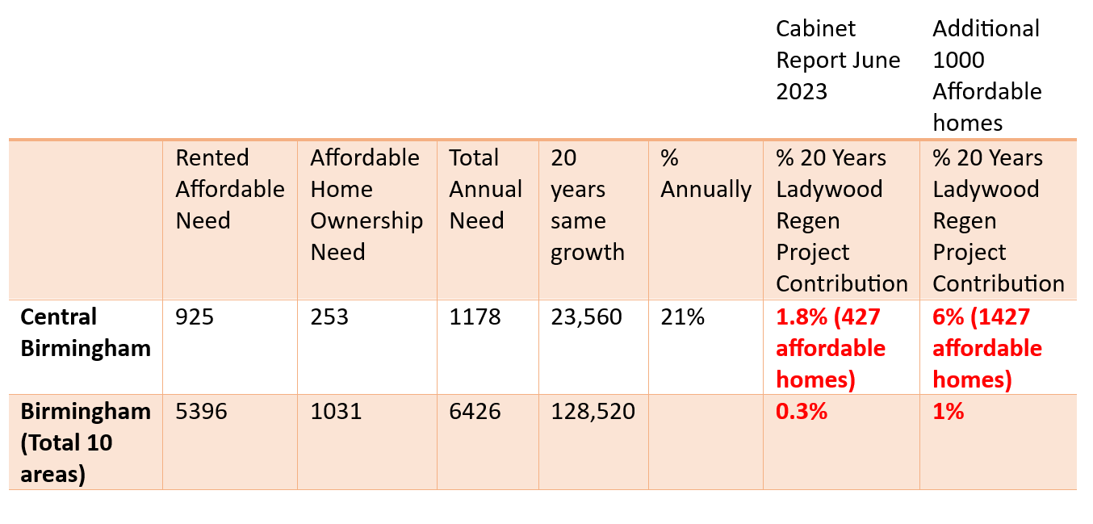
- Birmingham City Council has a documented track record of under-delivering on its promised affordable housing provision. According to two Freedom of Information (FOI) requests, between 2012/13 and 2022/23, 8,378 affordable homes were approved at the planning stage, yet only 4,375 were ultimately delivered. This significant shortfall has raised serious concerns that the Council is failing to properly oversee developers, particularly when they use value-engineering tactics to reduce or remove their Section 106 (S106) obligations by the time projects reach completion.
- Berkeley Homes also has a track record of under-delivering on its affordable housing commitments. For example, in December 2024, Berkeley Homes informed Southwark Council that it was reducing its affordable housing offer on the Aylesham Centre site from 35% to 12%. If a similar reduction were applied in Ladywood, the affordable housing provision would fall from 20% to below 7%.
- Request: To obtain clear and concrete assurances that no resident will be left worse off as a result of the regeneration scheme, including specific protections and guarantees to that effect. This includes establishing the proportion of proposed homes that will be genuinely affordable, with safeguards against reductions linked to developer profit margins or viability assessments. A firm commitment is also sought to guarantee residents’ unconditional right to remain in the area, and to exempt the replacement of existing homes from viability testing in line with Birmingham City Council’s pledge to retain the existing community, as set out in the Eight Principles of the 2019 Cabinet Report.
3. INDEPENDENT ADVICE ORGANISATION (IAO)
- Residents have serious concerns about procedural fairness and discriminatory practices in the appointment of an Independent Advice Organisation.
- During the selection process for appointing residents to the evaluation panel, Birmingham City Council staff used criteria such as “a significantly different age group” and “white ethnic backgrounds” to justify rejection from the evaluation panel, raising serious about potential breaches of the Equality Act concerns.
- In July 2023, Councillor John Cotton publicly committed to providing independent advice “to help, assist and support the local community during the lead-up to and during the consultation period.” That commitment was not honoured. Residents have continued to attend St Joseph's master planning events without access to the independent advice or support they were promised. Many have raised concerns that they lack the necessary knowledge and skills to make informed decisions during these events.
- Given the sheer number of households within central Ladywood, many of whom face varying levels of vulnerability and require tailored, high-quality, and sustained independent advice the funding allocation becomes deeply inadequate when divided across all affected households. The resulting per-household amount is negligible, raising serious concerns about the ability of the resource to provide meaningful and comprehensive independent advice and support.
- Request: A full investigation into potential procedural and discriminatory concerns. A transparent review of the funding formula used to determine the cost of appointing an Independent Advice Organisation, taking into account the level of resource required to adequately meet the needs of nearly 2,000 households.
4. RESIDENTS’ STEERING GROUP COMMITTEE
- There is concern over the recruitment and legitimacy of the proposed Steering Group:
  - No democratic process in place, residents appear to be appointed by TPAS, not elected.
  - TPAS’s involvement compromises the group’s independence.
- Request: A transparent, democratic process for resident representation, free from Council or contractor bias.

5. MAYOR OF WEST MIDLANDS – MEETING INVITATION U-TURN
- The Mayor has withdrawn from a planned meeting with residents and the developers following internal consultation with WMCA officers and the Council.
- This decision has undermined trust among residents and appears to signal political retreat from direct engagement.
- Concern: Erosion of trust caused by the Mayor’s decision to extend the initial invitation to meet with residents and the developer, but failing to follow through - ultimately missing a crucial opportunity to demonstrate high-level leadership and provide reassurance on a sensitive matter.

6. CONDITIONS IN TOWER BLOCKS
- Ongoing and unresolved reports from tower block residents concerning:
  - Fire risk, flooding, damp, mould, persistent leaks.
- Despite efforts from groups such as Acorn, the Council’s response remains inadequate.
- Request: It is not sufficient to simply accept the Council’s assurances. There must be clarity on what immediate inspection and remedial works are being undertaken, with a clear, demonstrable commitment to ensuring the safety and health of residents.

7. MULTIPLE MOVES FOR COUNCIL TENANTS
- The draft Residents Charter states it is “our intention” that council tenants remain on the estate with one move.
- This language lacks legal or binding clarity and leaves open the possibility of multiple relocations.
- Request: Strengthened and unambiguous guarantees for council tenants to remain on the estate with a single move.

8. IMPACT ON HOMEOWNERS & HOUSING ASSOCIATION TENANTS
- Leaseholders, freeholders, and Midlands Heart tenants are not guaranteed a right to remain or return to the estate under current proposals.
- Request: Commitments that these residents can stay or return on a like-for-like basis without incurring financial loss.

9. MENTAL HEALTH SUPPORT – BIRMINGHAM MIND
- The Birmingham Mind sessions, commissioned by BCC, have been poorly attended and widely regarded as ineffective. Most of the Wednesday sessions had one attendee.
- Residents have stated the issue is material, not psychological.
- Your December 2024 survey reported that 86% of 167 respondents experienced a negative impact on their mental health.
- Even Mind has acknowledged they cannot offer meaningful support “whilst the Council holds a knife at the throats of residents.”
- Request: A rethinking of meaningful support provision, with a focus on reducing the causes of stress and hardship.

10. SOCIAL VALUE FAILURES
- The social value proposals currently presented do not focus on improving outcomes for the local Ladywood community.
- This appears to breach the Public Services (Social Value) Act 2012, which requires regeneration to enhance the economic, social, and environmental well-being of the relevant area.
- The Equality Analysis published in the 2023 Cabinet Report was fundamentally limited by its emphasis on justifying the scheme’s perceived benefits, while downplaying or overlooking the substantial negative socio-economic impacts acknowledged for residents.
- Request: A comprehensive, independently-led assessment of the regeneration’s impact on the community, alongside a full reassessment of social value priorities that are specifically tailored to the needs and aspirations of Ladywood residents.
11. LACK OF TRANSPARENCY
- The Council is withholding crucial information regarding its agreement with Berkeley, particularly around housing numbers and development phasing.
- This lack of transparency obstructs residents’ ability to meaningfully engage in master planning workshops.
- Request: Immediate publication of all agreements and planning details affecting residents’ futures.

